STAY INFORMED, GET INVOLVED, MEET NEW PEOPLE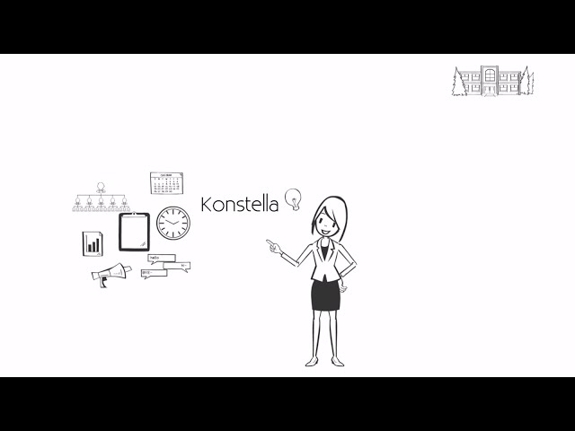
Sign-on to the Skyview Community at Konstella,
Skyview’s Communication Tool for Parents

Dear Parents & Guardians,
Welcome to the 2019-2020 school year at Skyview!
To keep everyone informed in the most effective way possible, all Methacton Home & School Associations utilize a communications system called Konstella. This system allows the Home & Schools to reach the school community in the most efficient way possible. The system has many features which we hope that you will take advantage of such as committee signups, parent groups, calendaring, and announcements.
To get started:
- Go to https://www.konstella.com, and select ‘Find Your School’ in the upper right hand corner and start to type out ‘Skyview’. ‘Skyview Upper Elementary’ will automatically populate and you may proceed to submit the request. This will trigger the approval request for the School’s administrators. This happens in daily batches every 24 hours.
- Once an Admin at the school approves the request to join, the parent will receive a follow up invitation to complete their registration. It’s a two-part process and all rising parents must request to join (i.e. no one is rolled-over to their new school.
We look forward to working with you and keeping you informed in helping our community grow!
Best regards,
Andrew Filshill, Skyview Home & School President
Laurie O’Neill, Skyview Home & School Corresponding Secretary

